A network administrator is connecting hosts A and B directly through their Ethernet interfaces, as shown in the illustration. Ping attempts between the hosts are unsuccessful. What can be done to provide connectivity between the hosts? IP Address: 192.168.1.20 Mask 255.255.255.240 IP Address: 192.168.1.201 Mask 255.255.255.240

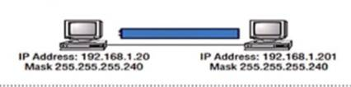

Step 1: Answer

The straight-through wire has to be replaced with a crossover cable.

255.255.255.0 should be used as the subnet mask.

Step 2:

Explanation:

First, a crossover cable is required if two hosts are linked directly, as in the case of the graphic. Straight-through cables are ineffective. Second, the hosts are in various subnets because of their various masks. The easy solution is just to set both masks to 255.255.255.0 (/24).

You need to configure a server that is on the subnet 192.168.10.56/29. The router has the last available host address. Which IP will you assign to the server?

Step 1: Answer

192.168.19.26 255.255.255.248

Step 2: m

A /29, or the fourth octet's block size of 8, is 255.255.255.248. These are the subnets: 0, 8, 16, 24, 32, etc. The broadcast address for the 24 subnet is 31 because 192.168.19.24 is the 24 subnet and 32 is the following subnet. Only 192.168.19.26 is the correct answer